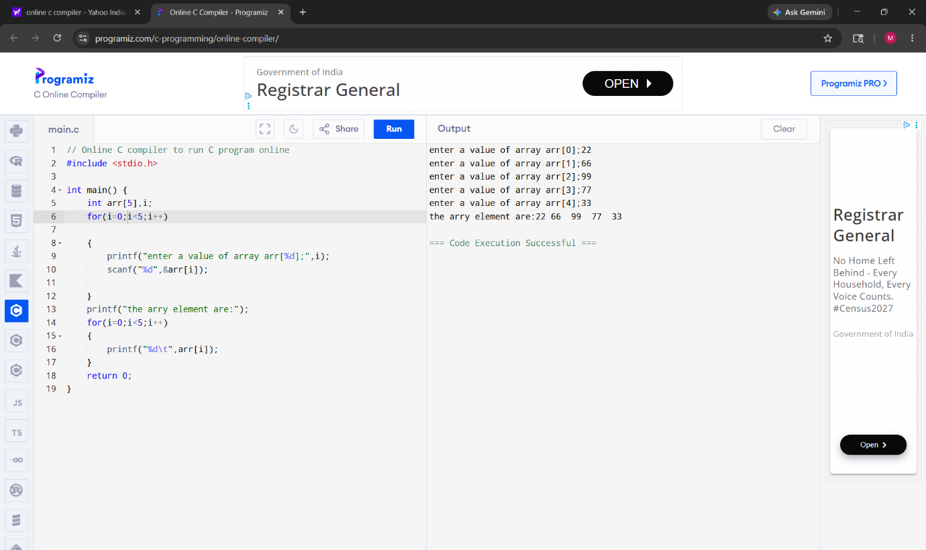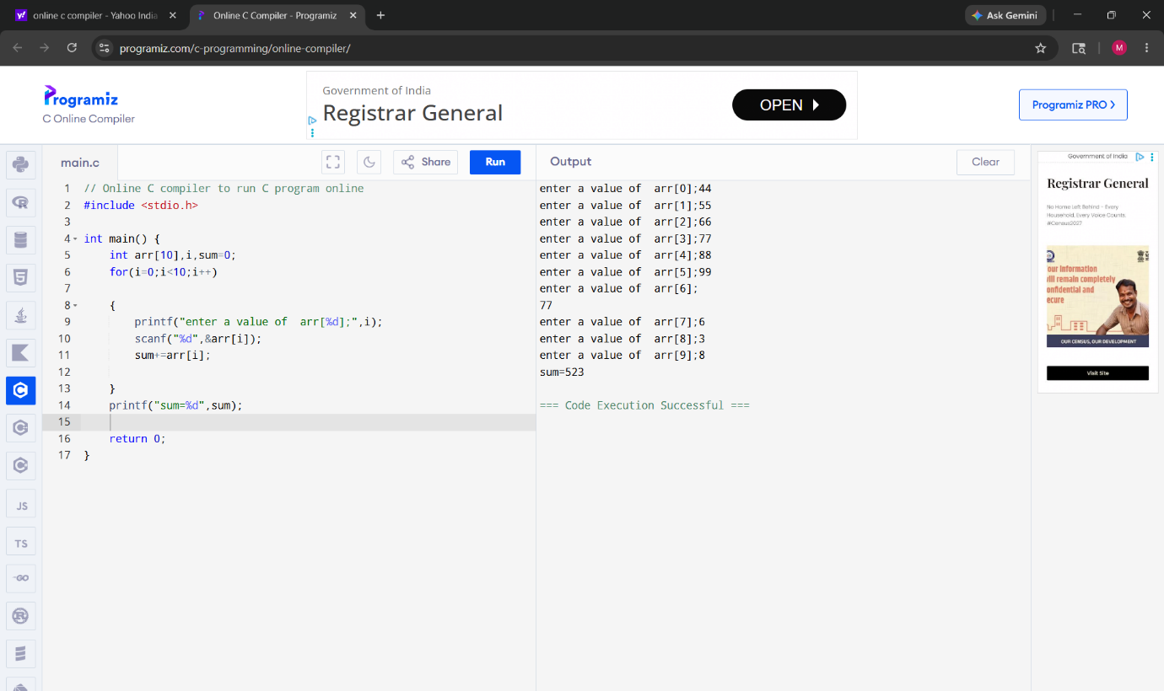
// Online C compiler to run C program online
#include <stdio.h>

int main() {
int arr[10],i,even=0,odd=0;
for(i=1;i<10;i++){
printf("enter a value for arr[%d]:",i);
scanf("%d,&arr[i");
if (arr[i]%2==0)
even++;
else
odd++;

}
printf("even=%d and odd=%d",even,odd);
return 0;
}
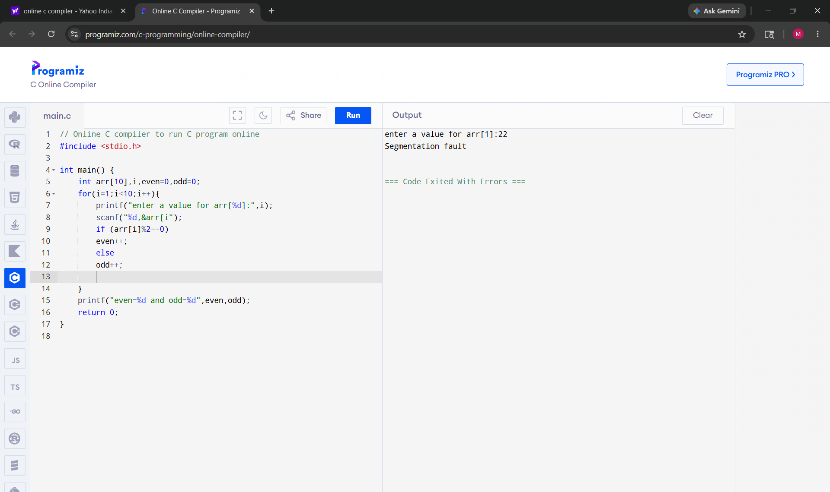

#include <stdio.h>

int main() {
int arr[10]={2,3,1,11,4,10,33,7,2,5};
int small,large,i;
small=large=arr[0];
for(i=0;i<10;i++){
if (arr[i]<small)
small=arr[i];
if(arr[i]>large)
large=arr[i];

}
printf("small=%d and large=%d",small,large);
return 0;
}
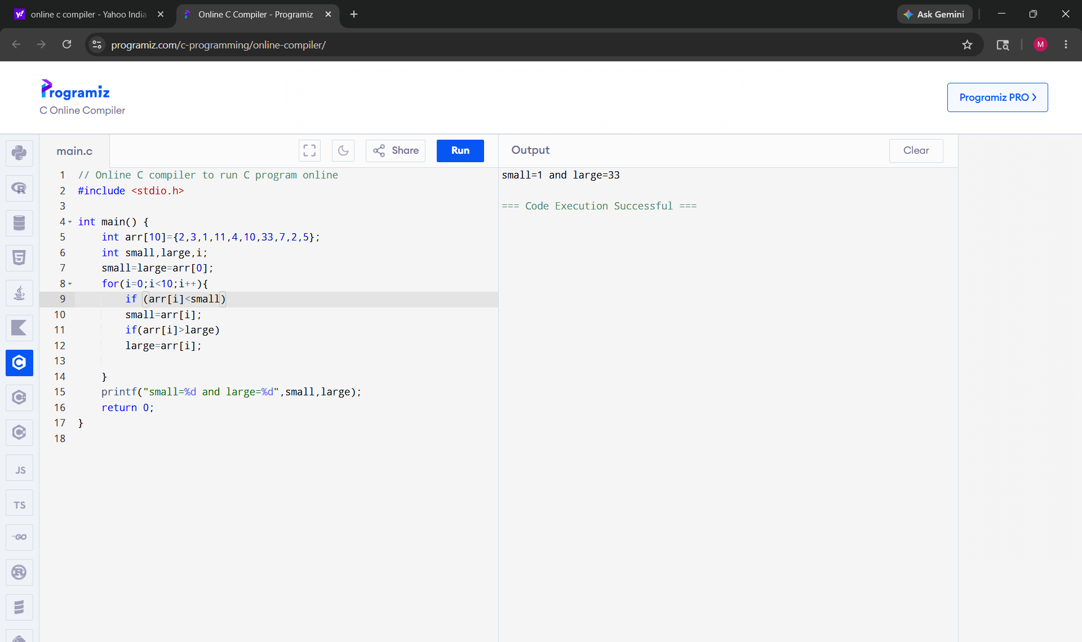
#include <stdio.h>

int main() {
for(int i=1;i<=3;i++)
{
for(int j=1;j<3;j++)
{
printf("%d",i);
printf("\n");
}

}
return 0;
}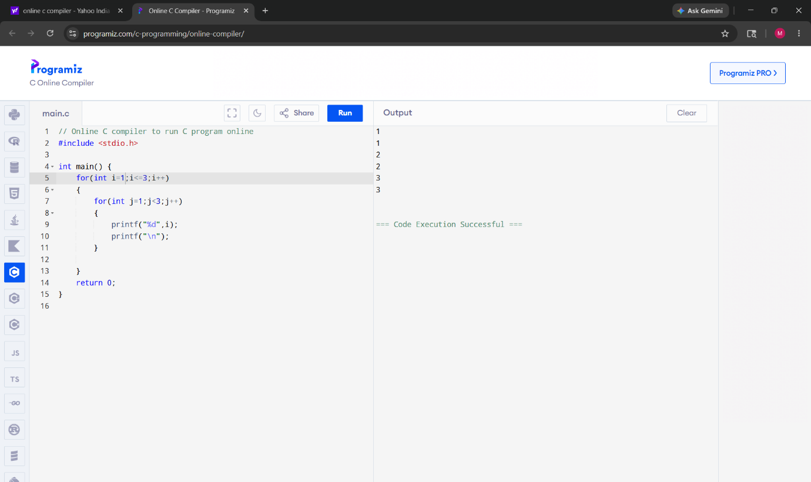
#include <stdio.h>

int main() {
int i,j;
int matrix[4][3]={ {1,2,3},
{4,5,6},
{7,8,9},
{10,11,12}
};
for(i=0;i<4;i++)
{
for(j=0;j<3;j++)
{
printf("matrix[%d][%d]",i,j);
printf("%d\t",matrix[i][j]);

}

printf("\n");
}
return 0;
}
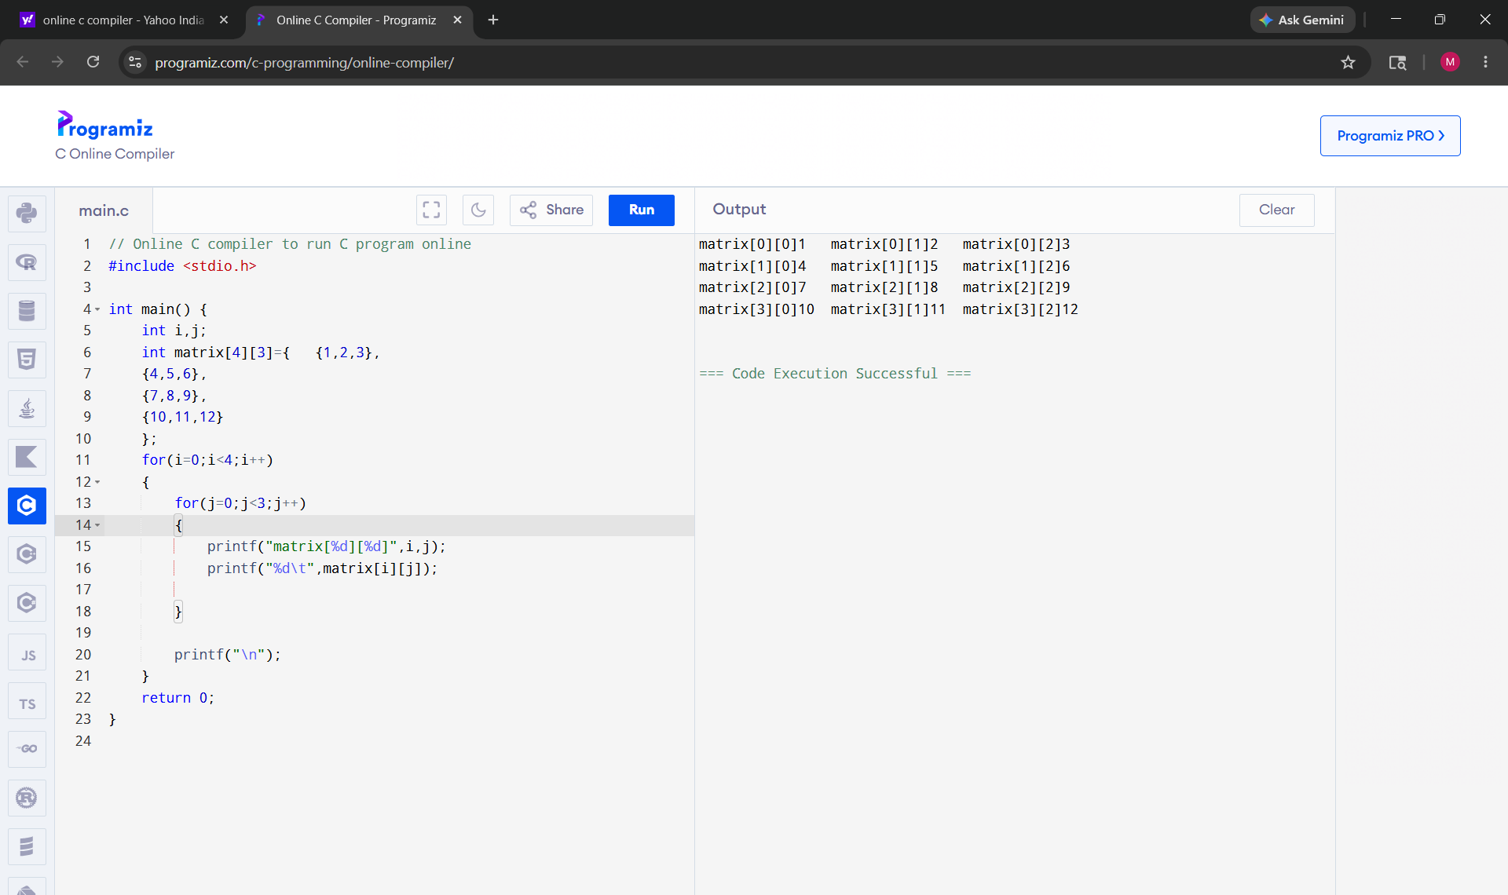
#include <stdio.h>

int main() {
int a=65;
printf("a=%c",a);

return 0;
}

Day 2
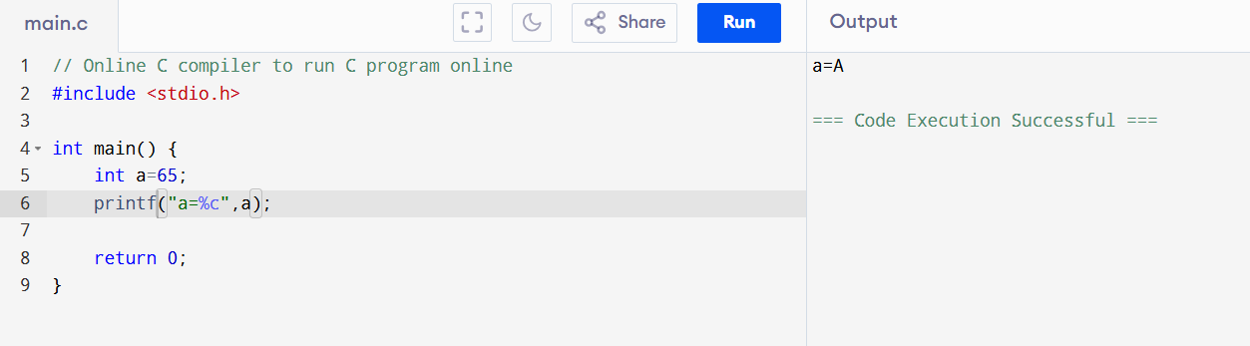
ASCII alphabet characters are the letters 'A' through 'Z' and 'a' through 'z', which are assigned numbers 65 through 90 and 97 through 122 in the ASCII character encoding standard.
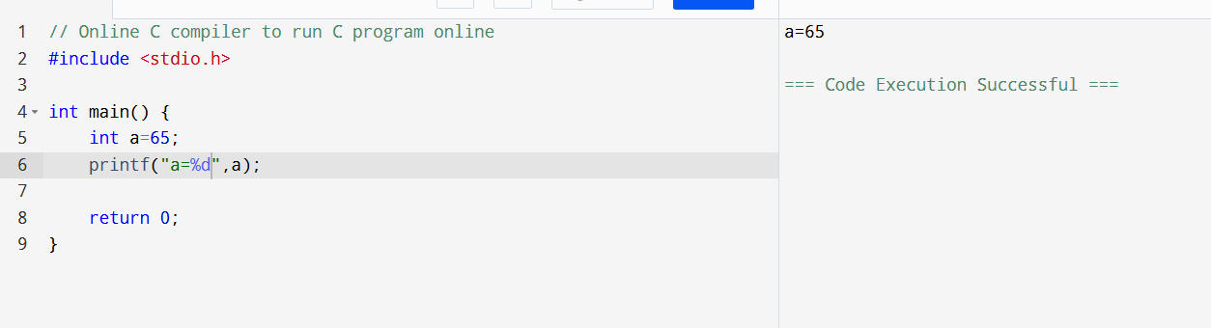

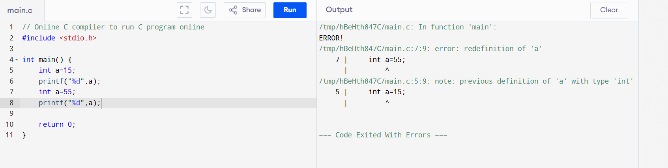
#include <stdio.h>
int main()
{
int a=32000;
long v=56000;
char ch='A';
float fl=3.14;
double d=12.154;
printf("\n%d",a);
printf("\n%ld",v);
printf("\n%c",ch);
printf("\n%f",fl);
printf("\n%lf",d);
return 0;
}

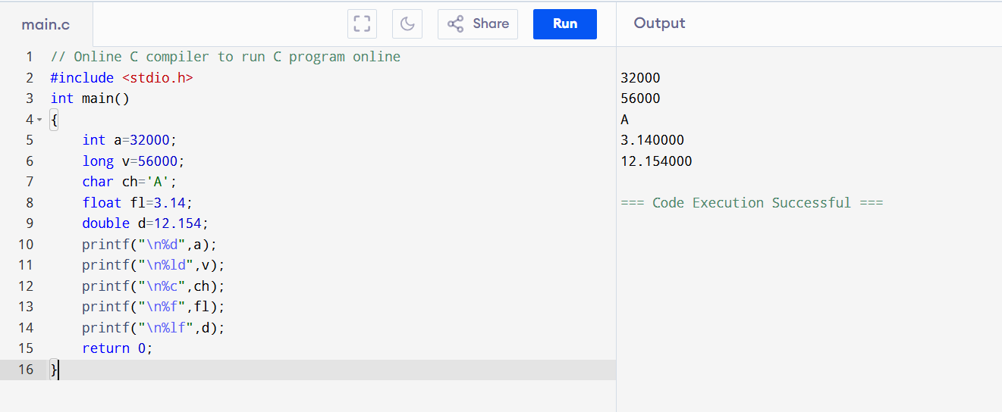

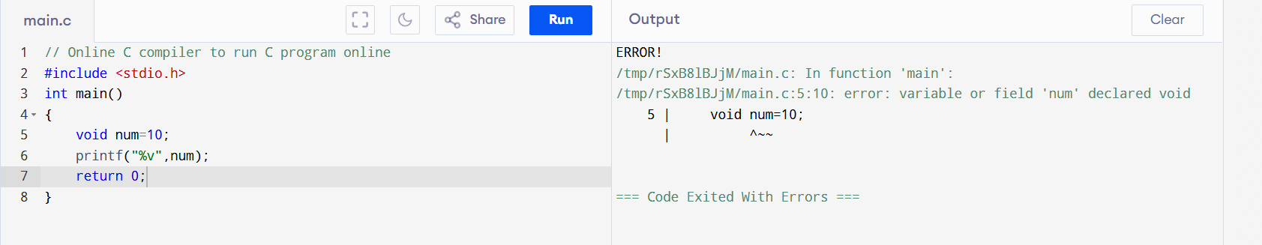

#include <stdio.h>
int main()
{
int i=5;
int a=++i + ++i;
printf("%d",a);
return 0;
}
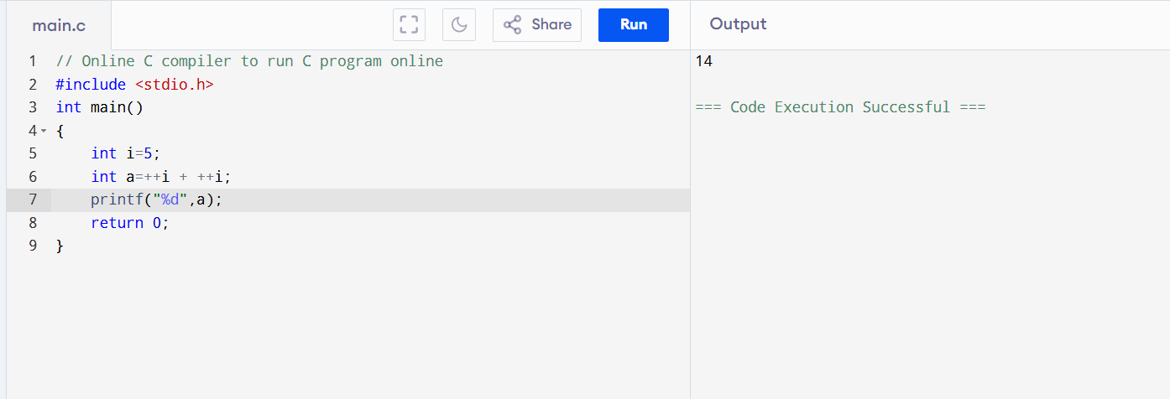
first ++i → 6
second ++i → 7

6 + 7 = 13
i becomes 7 first

7 + 7 = 14
because it used value 7 two times.

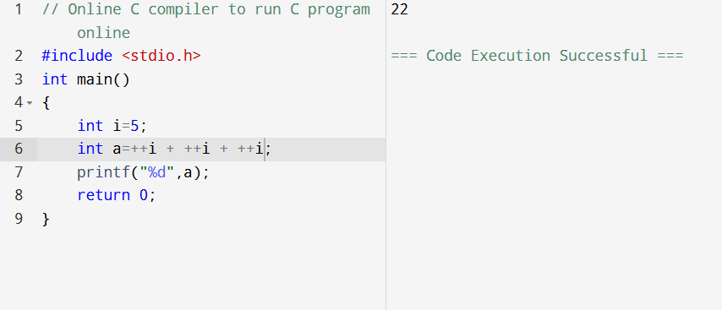

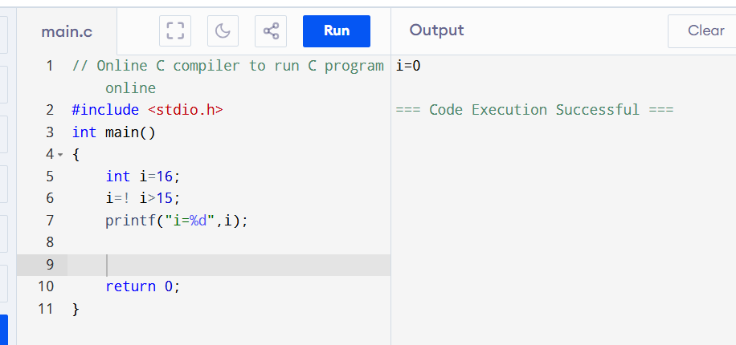

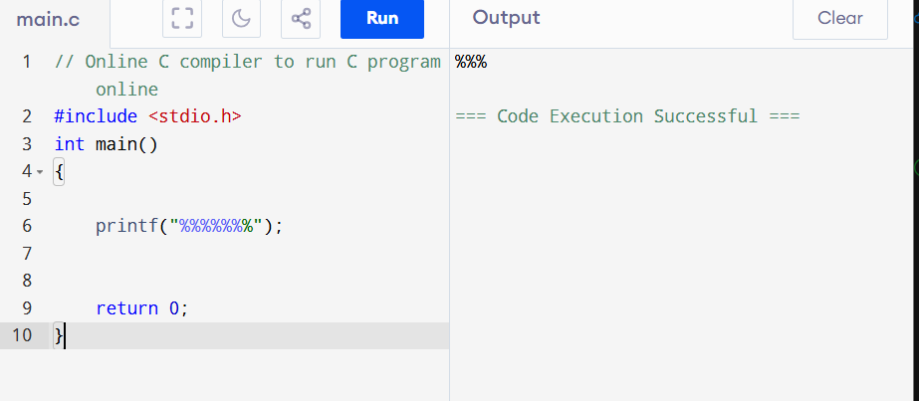

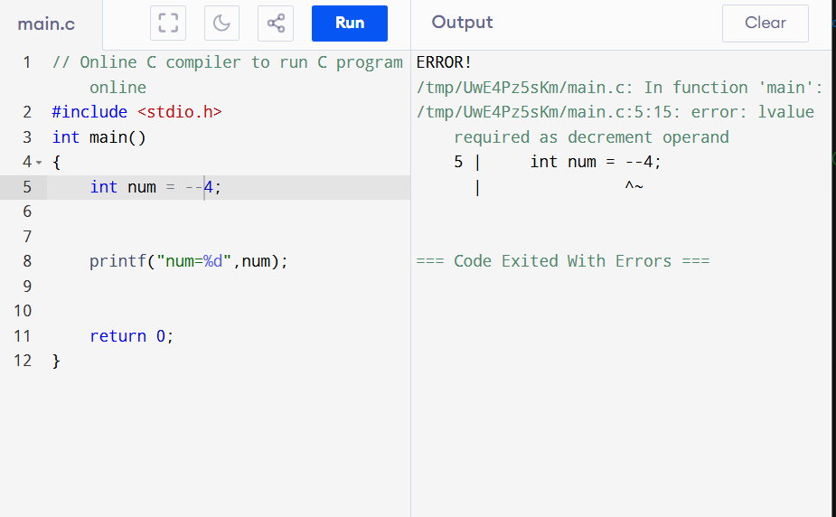

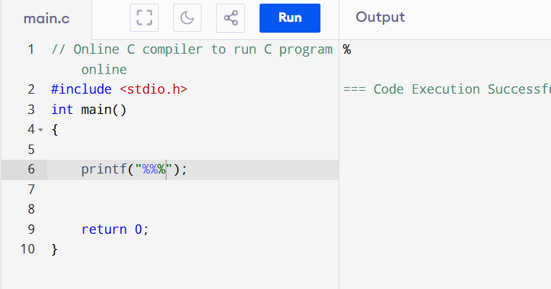

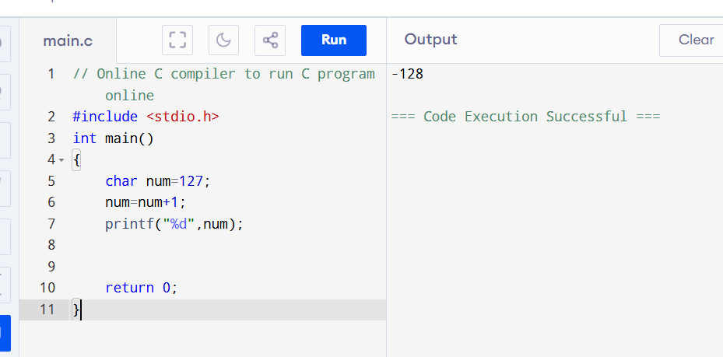

#include <stdio.h>
int main()
{
int a=5;
a = 1,2,3;
printf("%d",a);

return 0;
}

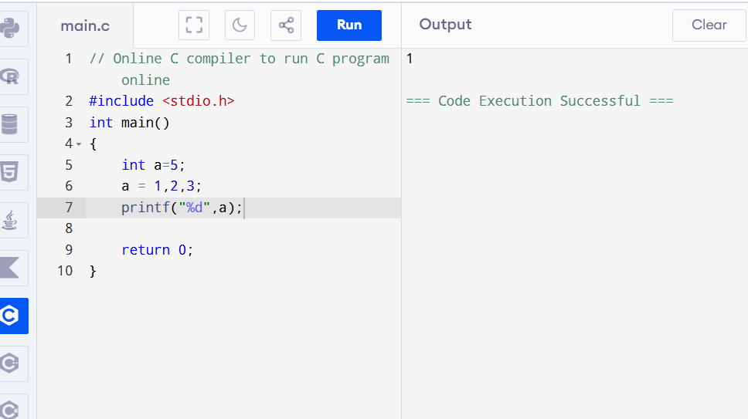

#include <stdio.h>
int main()
{
int a=5;
a =( 1,2,3);
printf("%d",a);

return 0;
}

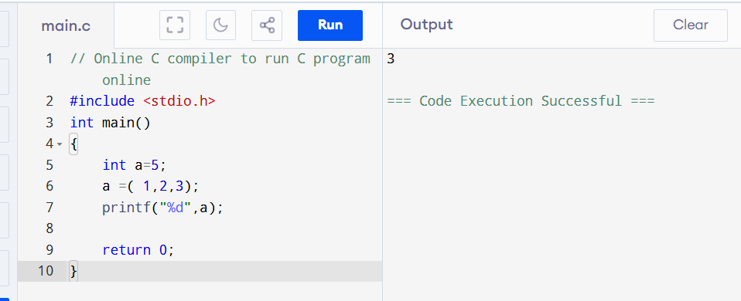
For bracket it cheak for right to left anf for withoit bracket it cheak for left to right

#include <stdio.h>
int main()
{
int i=10;
i++;

printf("%d\n",i);

return 0;
}
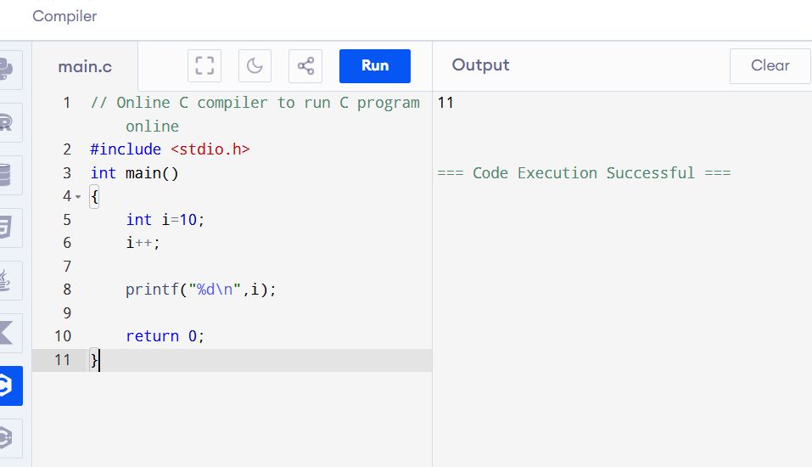

#include <stdio.h>
int main()
{
int i=0,j=0;
if(i++ ==j++)
printf("%d%d",i--,j--);
else
printf("%d%d",i,j);

return 0;
}

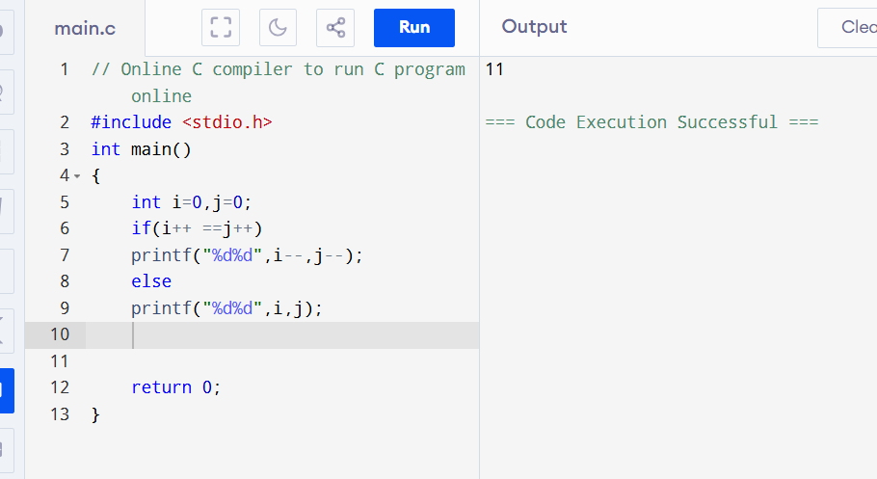

#include <stdio.h>
int main()
{
char str[8]="if block";
if(str =="if block")
printf("if block executed");
else
printf("else block executed");

return 0;
}

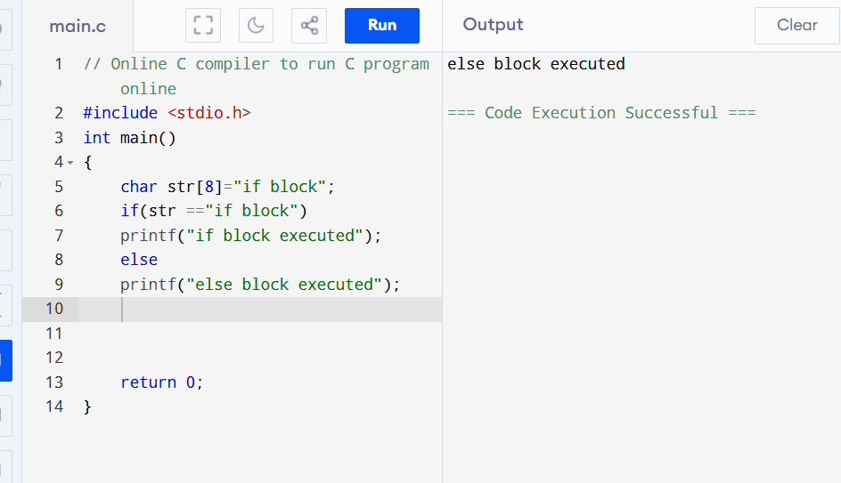

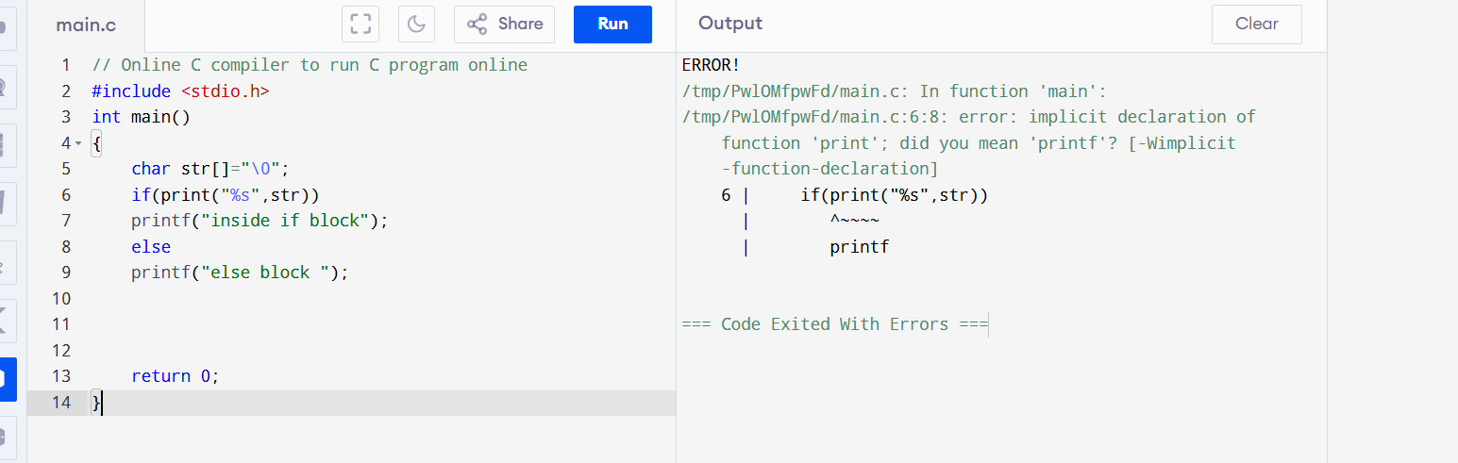
There is no function named print() in C.

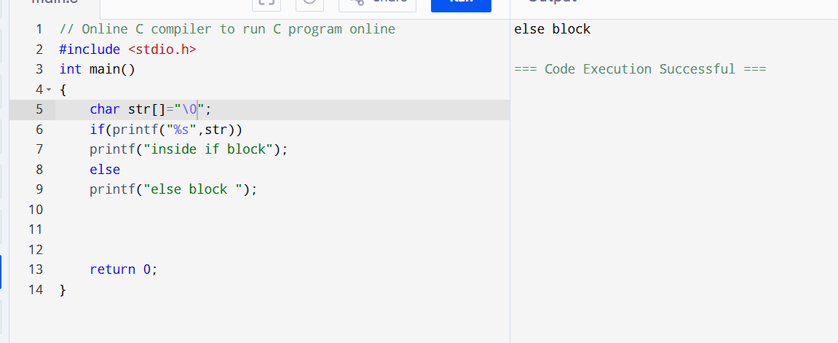

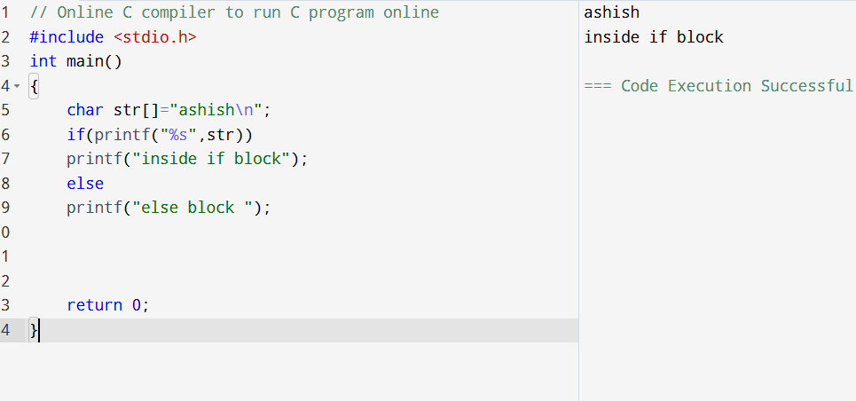

#include <stdio.h>
int main()
{
int i=5,j=4;
if(!printf(""))
printf("%d",i,j);
else
printf("%d%d",i++,j++);

return 0;
}

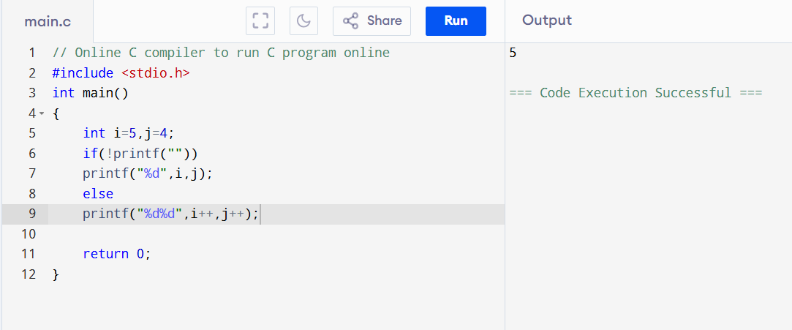
printf("") returns 0 because nothing is printed, and !0 becomes 1, so the if block executes.
printf("%d", i, j) has only one %d, therefore only value of i (5) is printed.

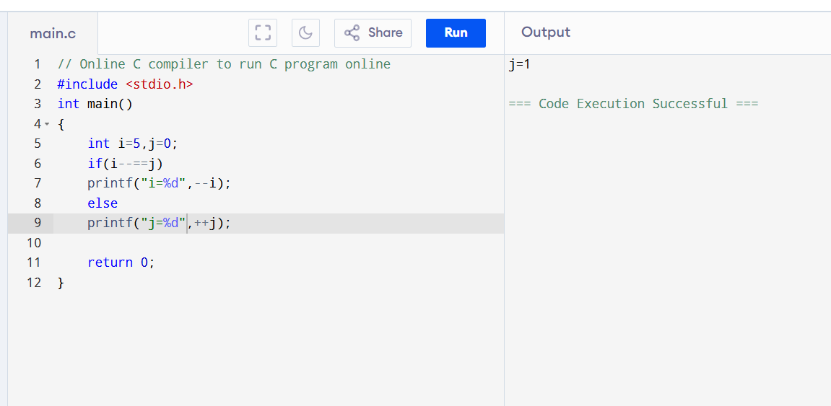

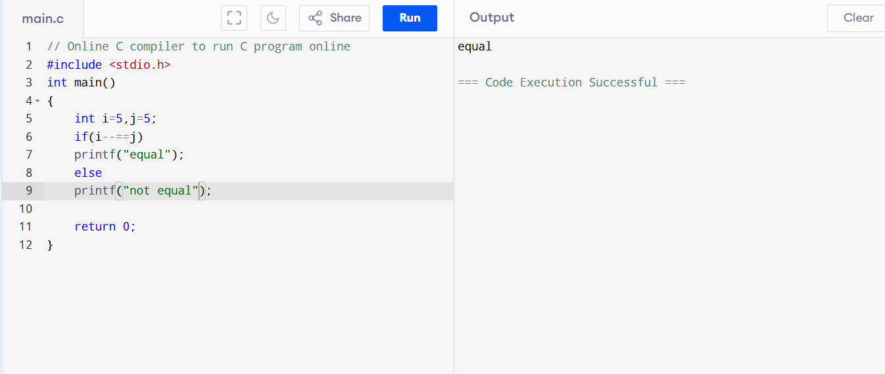

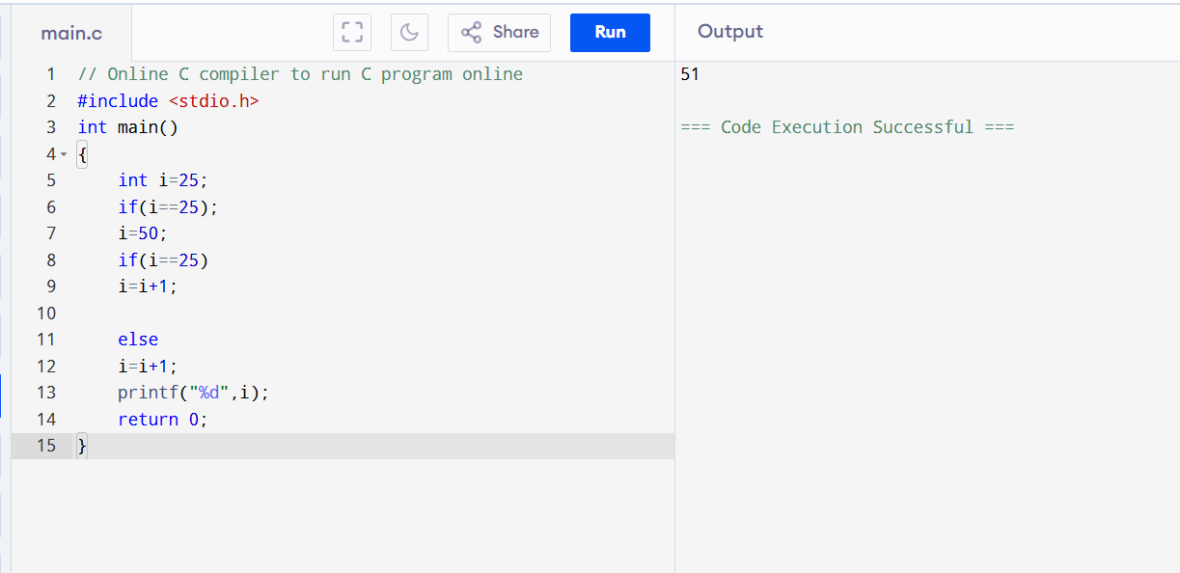

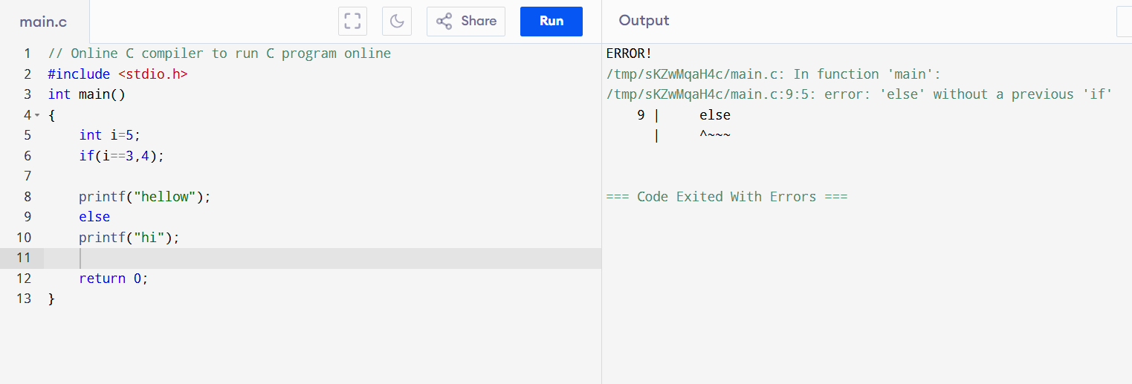

#include <stdio.h>
int main()
{
if(sizeof(0))
printf("hi");
else
printf("hellow");

return 0;
}

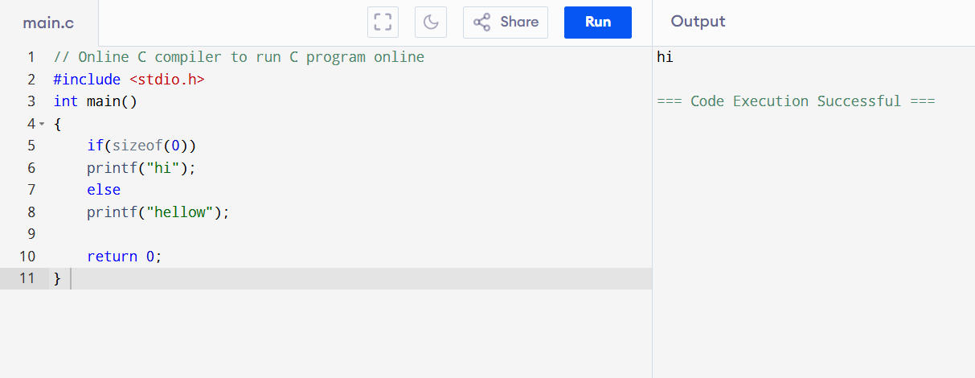

#include <stdio.h>
int main()
{
if(sizeof('\0'))
printf("inside if block");
else
printf("inside else block");

return 0;
}
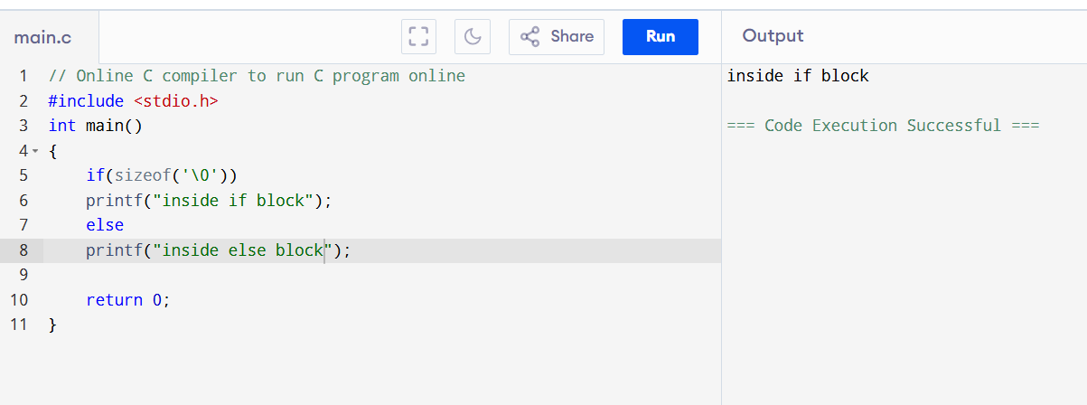

Input=aaabbbbccfff
Opt=a3b4c2f5

Day 4

#include <stdio.h>

int main() {
int i,j;
for(i=1,j=1;i<=3;i++,j++)
printf("%d%d",i,j);

return 0;
}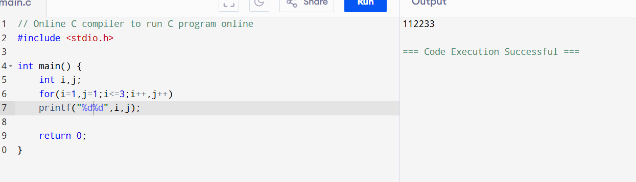

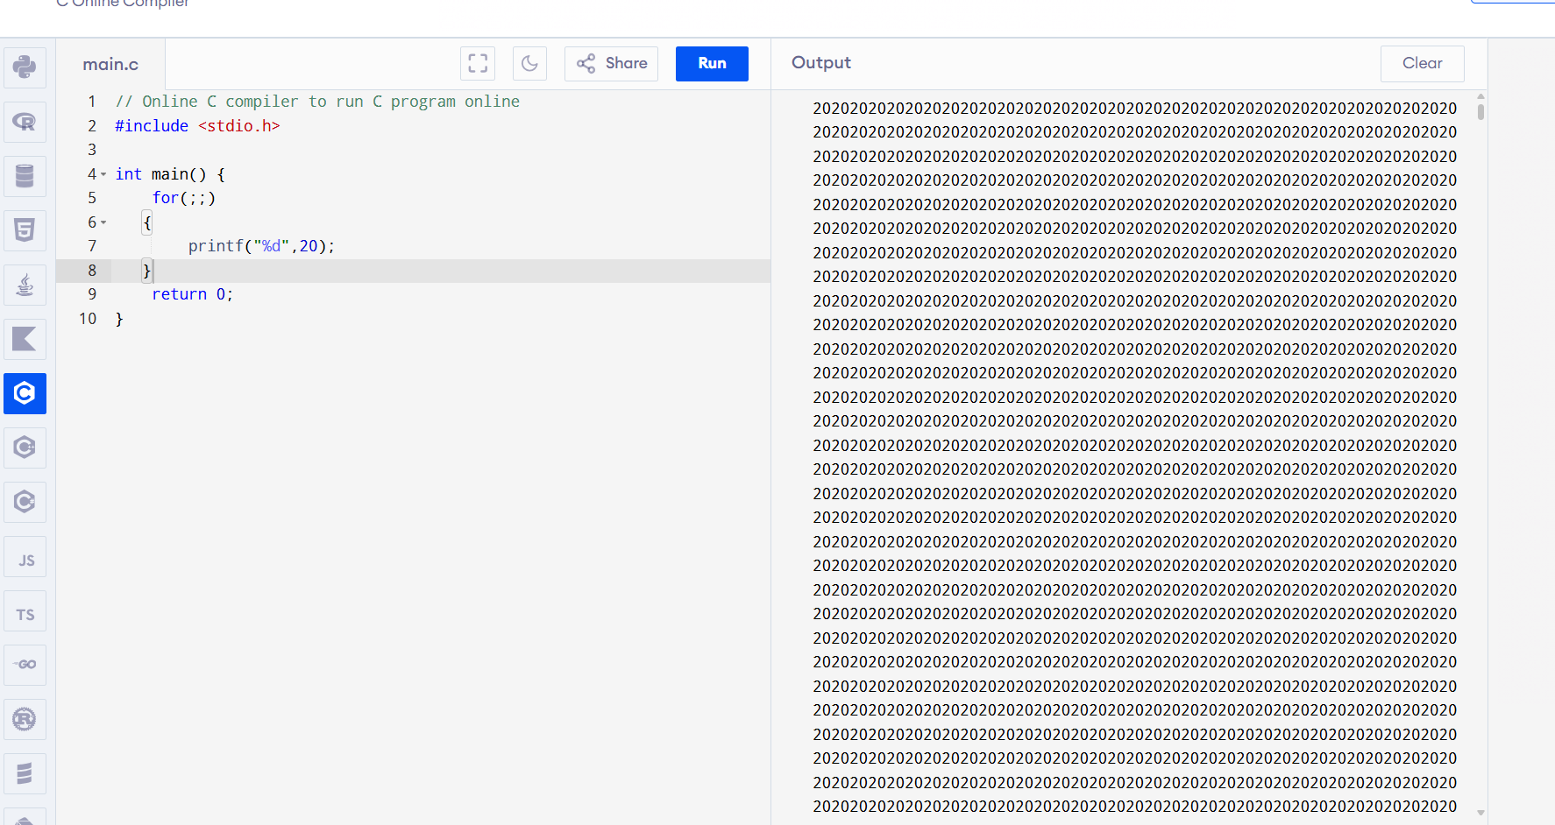
Infinite loop runs in this prog

#include <stdio.h>
int main()
{
int i;
for(i=0;i<=3;i++);
printf("%d",i);
return 0;
}
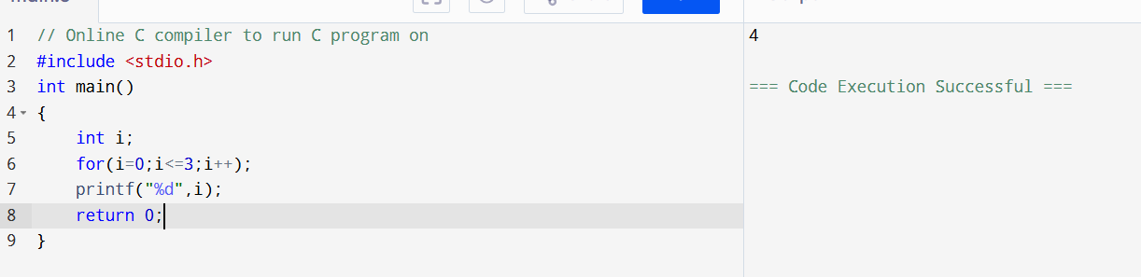

#include <stdio.h>
int main()
{
int i=0;
for(i=0;i==0;i++)
{
printf("%d",i);
}
return 0;
}
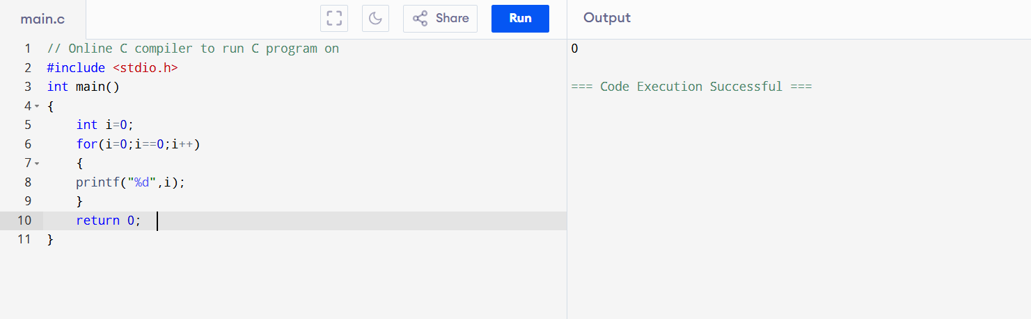

#include <stdio.h>
int main()
{
int i,j;

for(i=0,j=5;i<j;i++,j--)

printf("%d%d",i,j);

return 0;
}
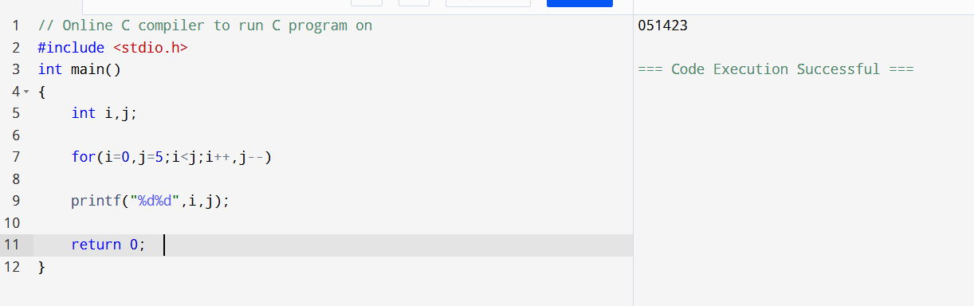

#include <stdio.h>
int main()
{
int i;

for(i=0;i<9;i=i+3)
{
printf("for");
}

return 0;
}

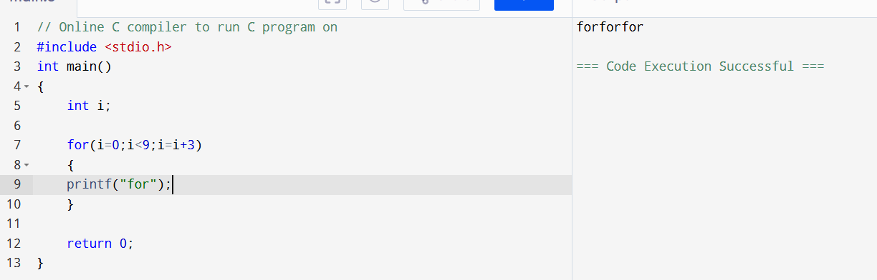

#include <stdio.h>
int main()
{
int i,sum=0;

for(i=0;i<10;i=i+3)
{
sum=sum+i;
}
printf("%d",sum);

return 0;
}
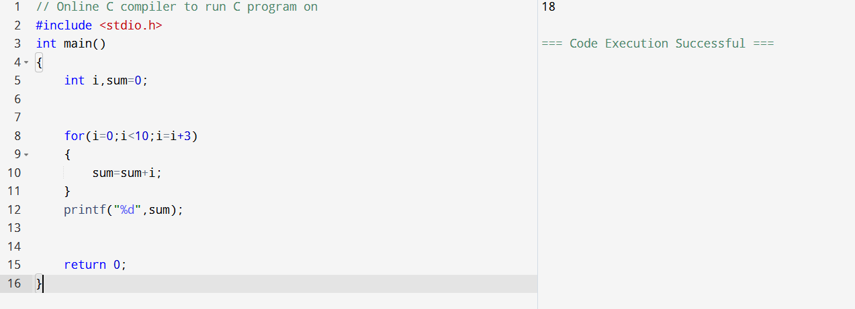i takes values 0, 3, 6, 9.
So sum = 0 + 3 + 6 + 9 = 18.

#include <stdio.h>
int x = -1;
int main(){
while(x++==1)
printf("loop");
return 0;
}
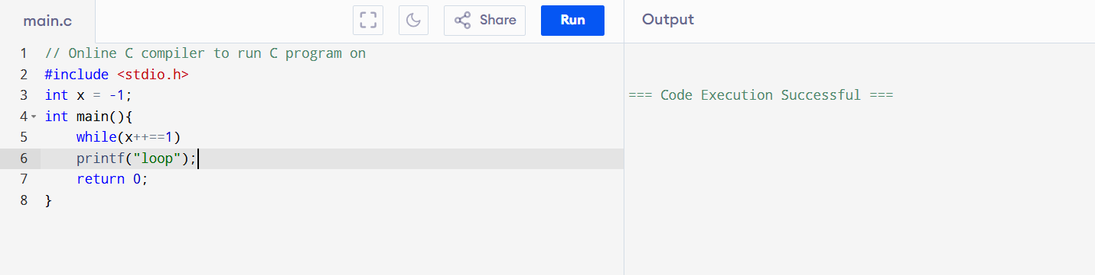
It print nothing

Initially x = -1, so condition x++ == 1 checks -1 == 1, which is false.
Since the condition fails in the first check, the while loop never executes.

#include <stdio.h>

int main(){
int i=5;
while(--i>0)
printf("Loop");
return 0;
}
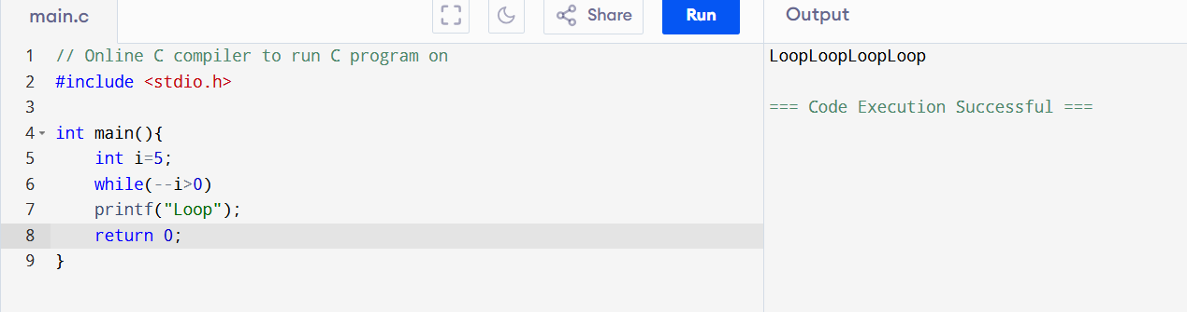
--i decreases i before checking the condition.
The loop runs for i = 4, 3, 2, 1, so "Loop" is printed 4 times.

#include <stdio.h>

int main(){
int i=0;
while(i++)
{
printf("Loop");
if(i==3)
break;
}
return 0;
}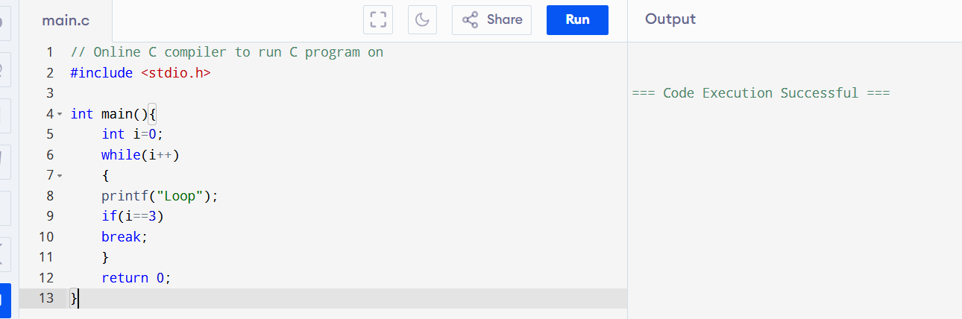
i++ uses the current value first, so the first condition checks 0, which is false.
The while loop never executes, so nothing is printed
(if i=0 in if while cond)

#include <stdio.h>
int main(){
while(!printf("help4code.com"));
return 0;
}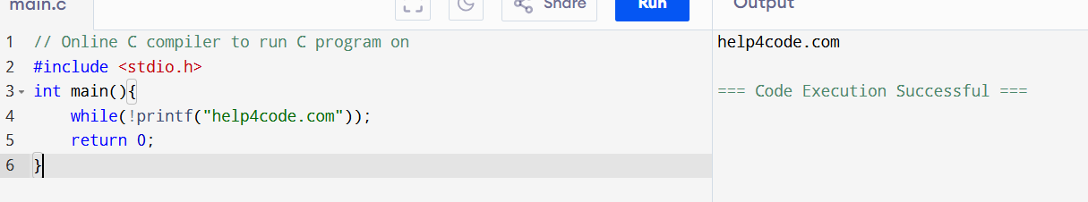
printf() prints "help4code.com" once and returns a non-zero value (13).
!13 is 0, so the while condition becomes false and the loop ends.

Array

#include <stdio.h>
int main(){
int arr[1]={2};
printf("%d",0[arr]);
return 0;
}
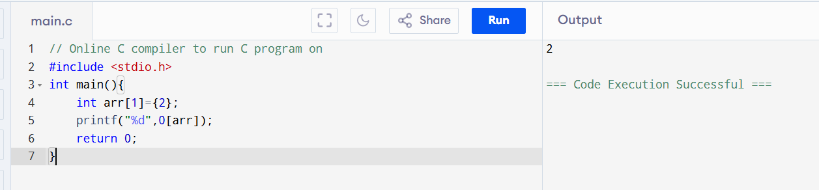
0[arr] is the same as *(0 + arr) = arr[0] = 2.

#include <stdio.h>
int main(){

int arr[3],i=0;
for(i=0;i<3;i++){
arr[i]=i;
}
for(i=0;i<3;i++){
printf("%d ",arr[i]);
}
return 0;
}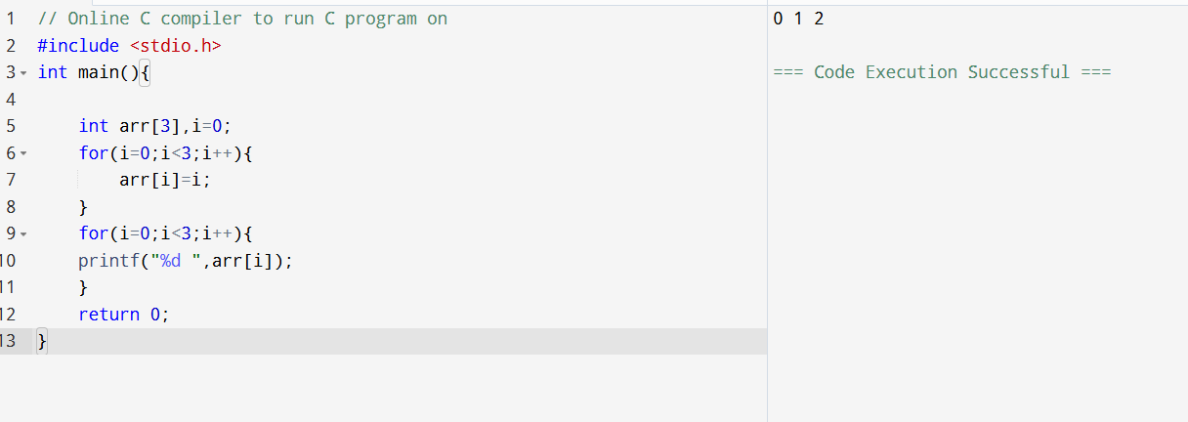The first loop stores 0, 1, and 2 in arr[0], arr[1], and arr[2].
The second loop prints all array elements in order.

#include <stdio.h>
int main(){
int arr[3],i,j;
arr[0]=11;
arr[1]=22;
arr[2]=33;
for(i=0;i<3;i++){
j=i;
}

printf("%d ",arr[j]);

return 0;
}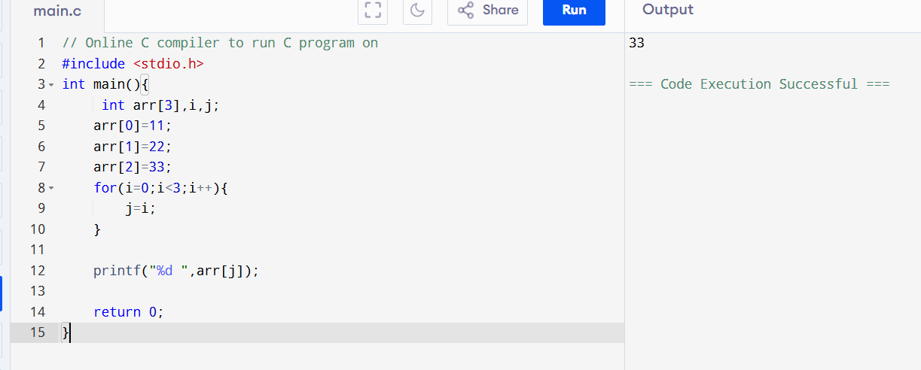
During the loop, j gets values 0, 1, and 2; the last valid assigned value is 2.
Therefore arr[j] = arr[2] = 33, so the output is 33

#include <stdio.h>
int main(){
int arr[3],i,temp;
arr[0]=11;
arr[1]=22;
arr[2]=33;
temp=arr[0];
arr[0]=arr[2];
arr[2]=temp;
for(i=0;i<3;i++)

printf("%d ",arr[i]);

return 0;
}

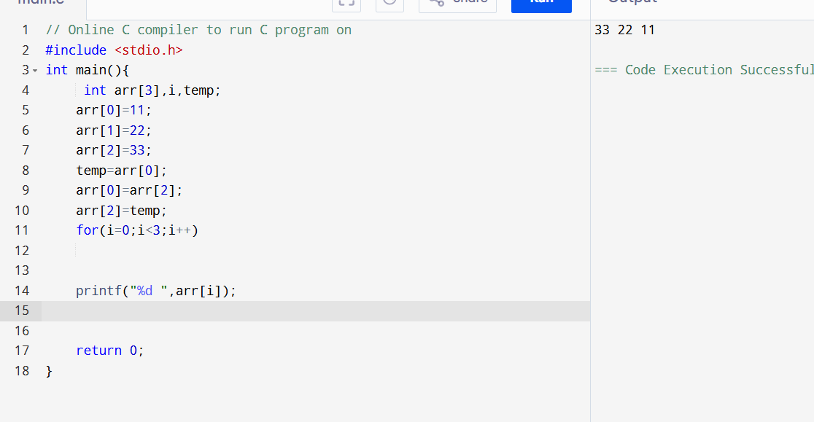

#include <stdio.h>
int main(){
char name[]="ashish";
int i;
for(i=0;i<6;i++){
printf("%c",name[i]);
}

return 0;
}
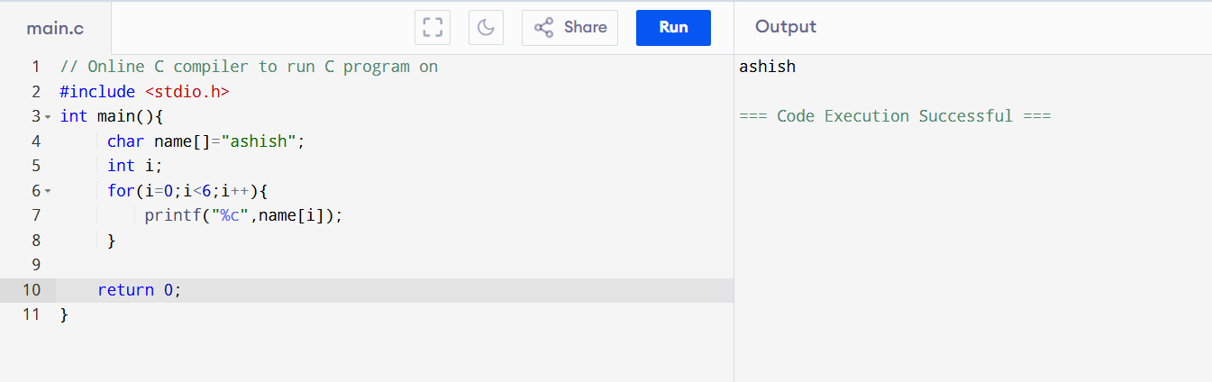The string "ashish" contains 6 characters: a, s, h, i, s, h.
The loop runs from i = 0 to 5 and prints each character once.

#include <stdio.h>
int main(){
char name[]="abcdef";
int i=0;

printf("%c",name[i]);
printf("%c",i[name]);
printf("%c",name[i+2]);
printf("%c",i[name+2]);

return 0;
}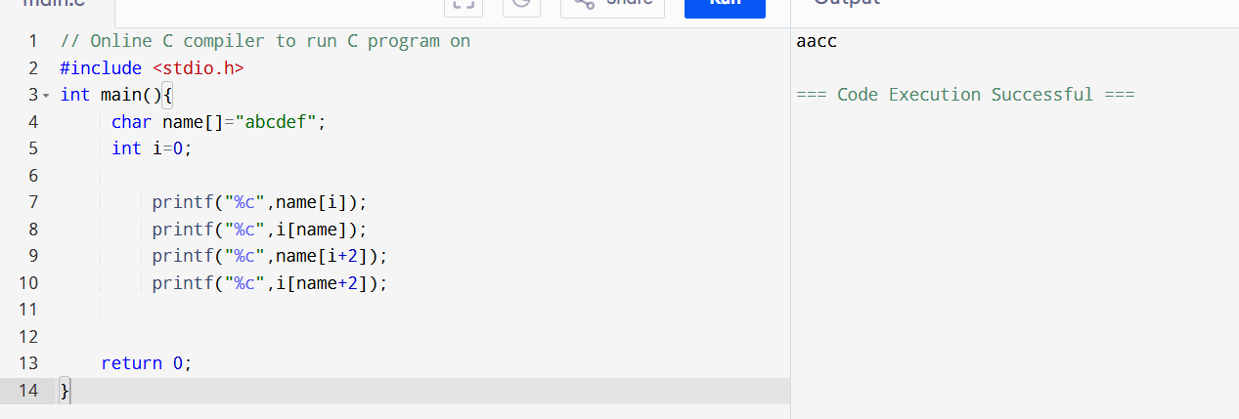name[i] and i[name] are the same, so both print a and b respectively.
name[i+2] prints c and i[name+2] is equivalent to (name+2)[0], which prints c; actually with i=0, outputs are a a c c → aacc.

#include <stdio.h>
#define arr "abcd"
int main(){
printf("%c",arr[2]);
return 0;
}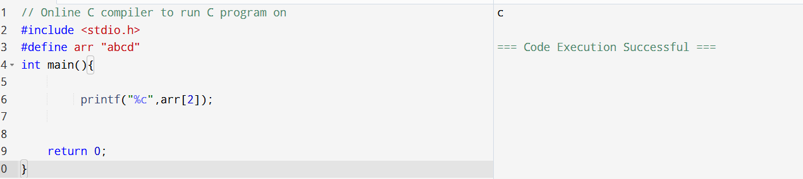
The macro arr is replaced by the string "abcd" before compilation.
arr[2] means the character at index 2, which is 'c'.

#include <stdio.h>

int main(){
int arr[2]={1,2,3,4,5};

printf("%d",arr[3]);

return 0;
}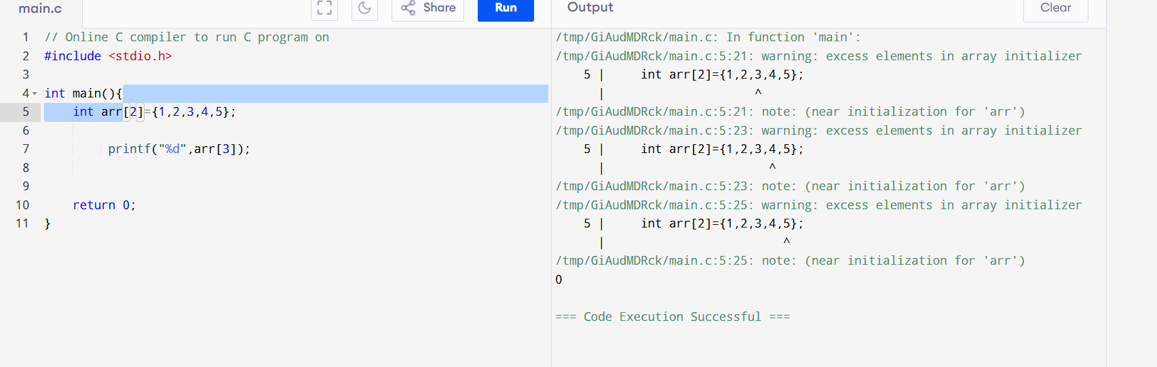

Array Size is 2 but samples are 5 therefore error,in some compiler it become 0 or garbage value

#include <stdio.h>

int main(){
int i=0;
char s[4]={'\0','\0','\0','\0'};
for(i=0;i<4;i++)
{

printf("%c",s[i]);
}

return 0;
}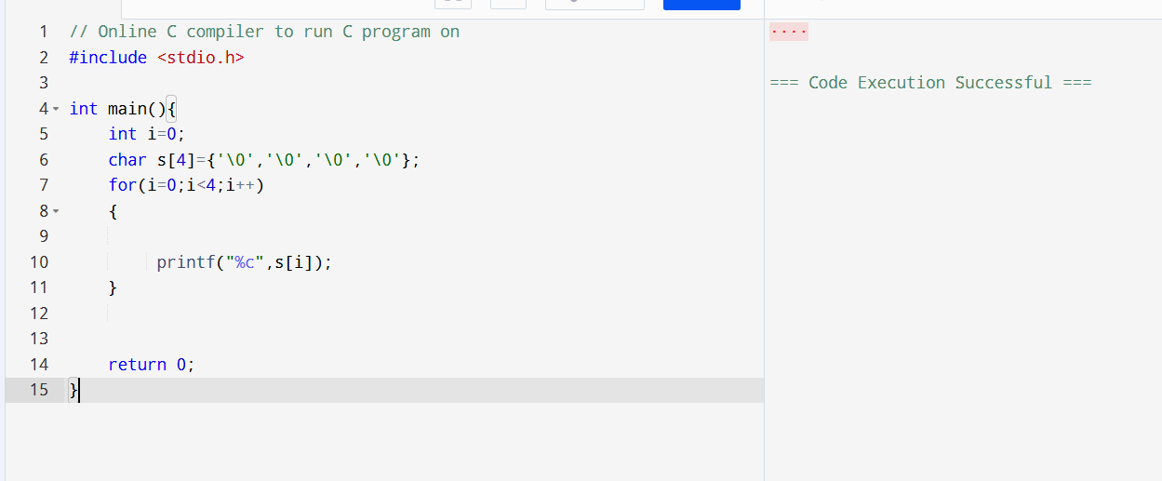
All elements of s contain '\0' (null character).
printf("%c", '\0') prints a null character, which is not visible on the screen.

#include <stdio.h>

int main()
{
int i, j;

for(i = 1; i <= 5; i++)
{
if(i == 3)
continue;

printf("%d %d\n", i, 6 - i);
}

return 0;
}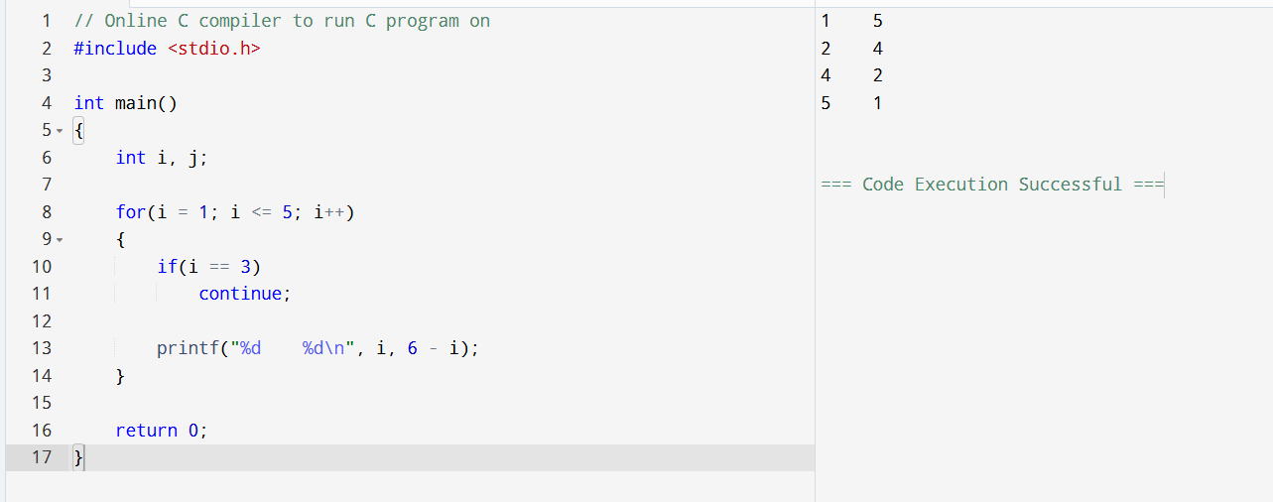
The loop runs from 1 to 5, and continue skips i = 3.
The second number is calculated as 6 - i.

Day 5
Pointers:
#include <stdio.h>

int main() {
int age=30;
float sal=1500.50;
printf("Address of age=%u\n",&age);
printf("address of salary=%u\n",&sal);

return 0;
}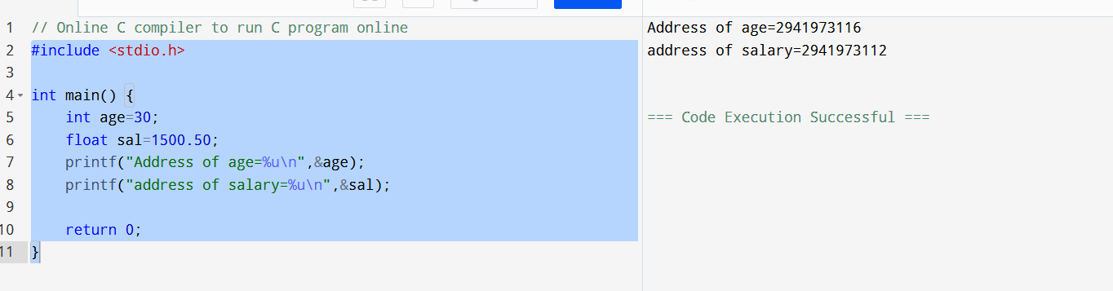
&age and &sal return the memory locations where the variables are stored.
Memory addresses depend on the system and program execution, so they change from run to run.

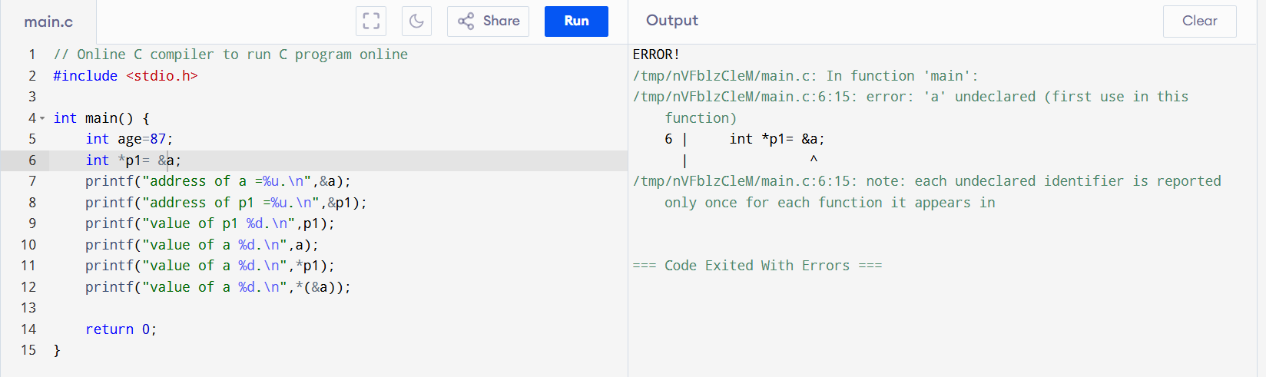
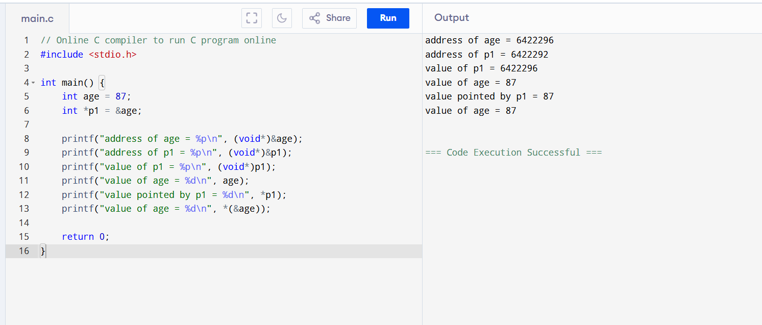
#include <stdio.h>

int main() {
char a='x',*p1=&a;
int b=12,*p2=&b;
float c=2.5,*p3=&c;
double d=18.33, *p4=&d;
printf("sizeof(p1) = %u,sizeof(*p1)=%u\n",sizeof(p1), sizeof(*p1));
printf("sizeof(p2) = %u,sizeof(*p2)=%u\n",sizeof(p2), sizeof(*p2));
printf("sizeof(p3) = %u,sizeof(*p3)=%u\n",sizeof(p3), sizeof(*p3));
printf("sizeof(p4) = %u,sizeof(*p4)=%u\n",sizeof(p4), sizeof(*p4));

return 0;
}
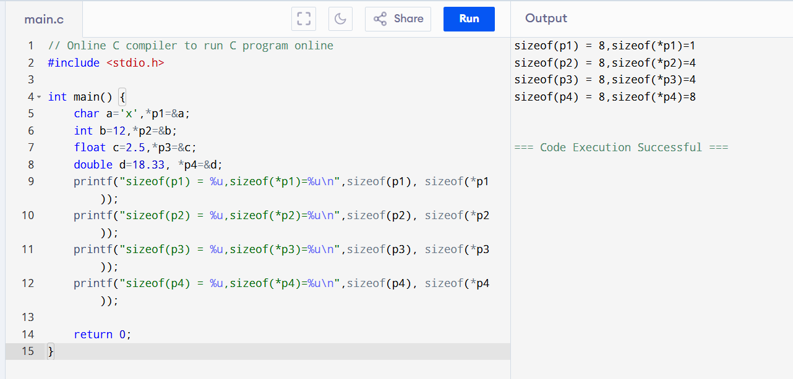
All pointers usually occupy 8 bytes on a 64-bit system.
sizeof(*p) gives the size of the data type being pointed to (char, int, float, double).

#include <stdio.h>

int main() {
int a=5,*pi=&a;
char b='x',*pc=&b;

float c=5.5,*pf=&c;

printf("value of pi=address of a=%u\n",pi);
printf("value of pc=address of b=%u\n",pc);
printf("value of pf=address of c=%u\n",pf);
pi++; pc++; pf++;
printf("now value of pi=%u\n",pi);
printf("now value of pc=%u\n",pc);
printf("now value of pf=%u\n",pf);

return 0;
}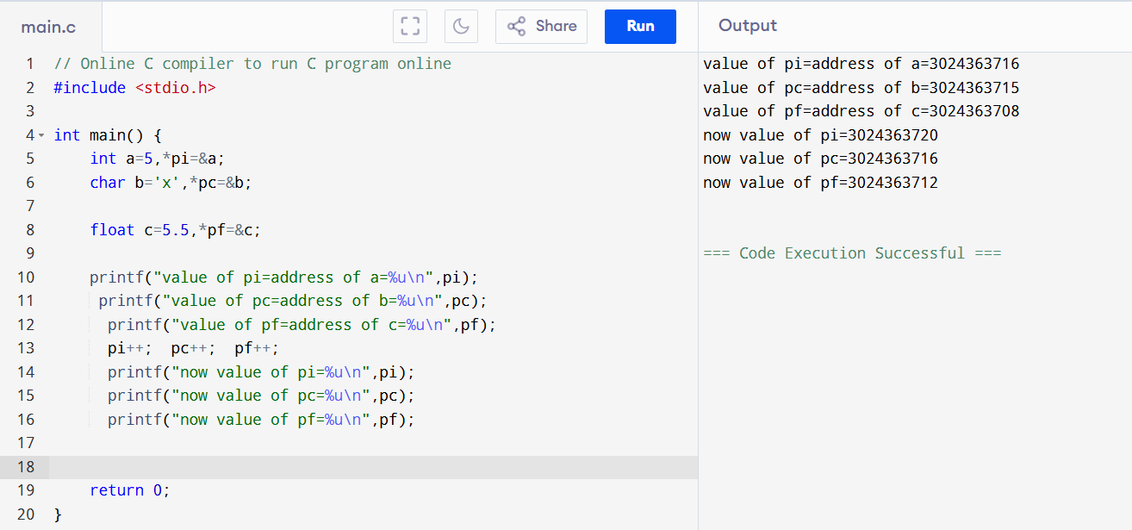
- pi, pc, and pf store the addresses of a, b, and c respectively.
- Pointer arithmetic increases the address by the size of the data type it points to.
- pi++ increases the address by 4 bytes (size of int).
- pc++ increases the address by 1 byte (size of char).
- pf++ increases the address by 4 bytes (size of float), so the new addresses are larger than the original ones.

#include <stdio.h>

int main() {
int arr[5]={5,10,20,25,30},i=0;
for(i=0;i<5;i++)
{

printf("value of a[%d]\n",i);
printf("%d\n",arr[i]);
printf("%d\n",i[arr]);
printf("%d\n",*(arr+i));
printf("%d\n",*(i+arr));
}
return 0;
}

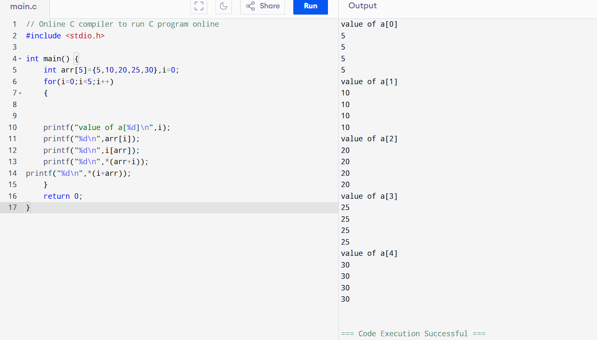
• arr[i] accesses the element at index i of the array.
• i[arr] is equivalent to arr[i] in C.
• *(arr+i) uses pointer arithmetic to access the same element.
• *(i+arr) is also equivalent to arr[i].
• Therefore, all four statements print the same value in each iteration.

#include <stdio.h>

int main() {
int a=66;
char *c;
c=(char*)&a;
printf("%d\n",*c);
printf("%c\n",*c);
return 0;
}

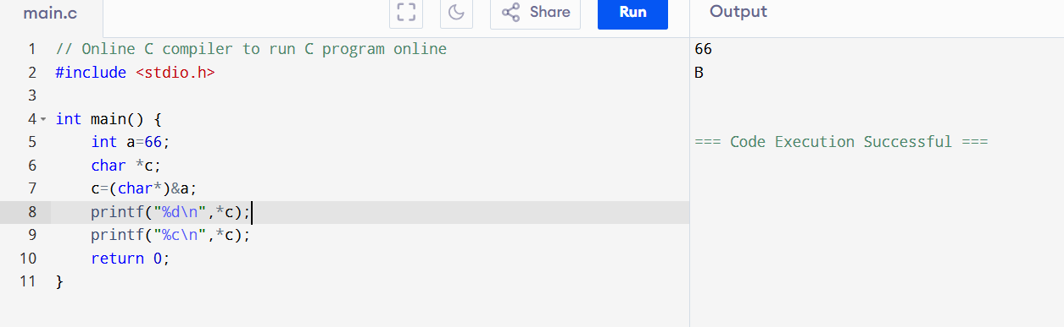
It is an explicite casting

#include <stdio.h>

void fun(int *);

int main() {
int arr[] = {3, 6, 9, 12, 15, 18};
fun(arr);
return 0;
}

void fun(int *p) {
int i;
for(i = 0; i < 6; i++) {
printf("%d\n", *p);
p++;
}
}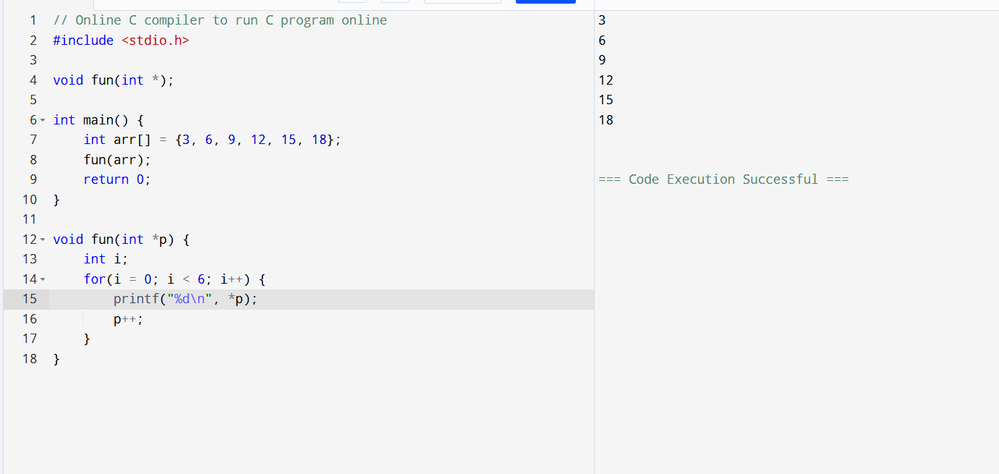
• arr itself represents the address of the first element of the array.
• Therefore, use fun(arr) instead of fun(&arr).
• The function parameter int *p receives the address of the first element.
• p++ moves the pointer to the next integer element in the array.
• The loop prints all array elements: 3, 6, 9, 12, 15, 18.

